**BRENT HENDRICKS**

**PROJECT**

**TERM 3 INDIVIDUAL**

**CODING PROGRESS**

I have no back end coding, only front end. I was responsible for the contact page. For my finally outcome for the task in term 4 I’d like to add a back end code, still working on it.

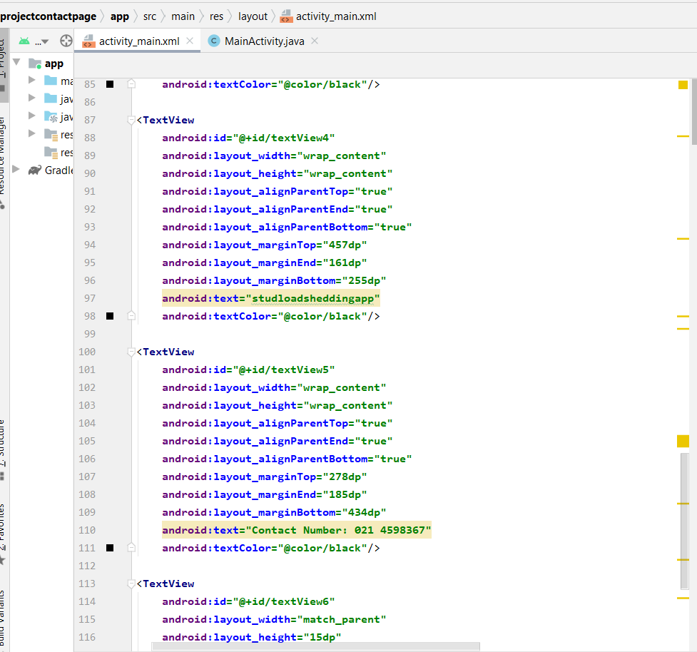

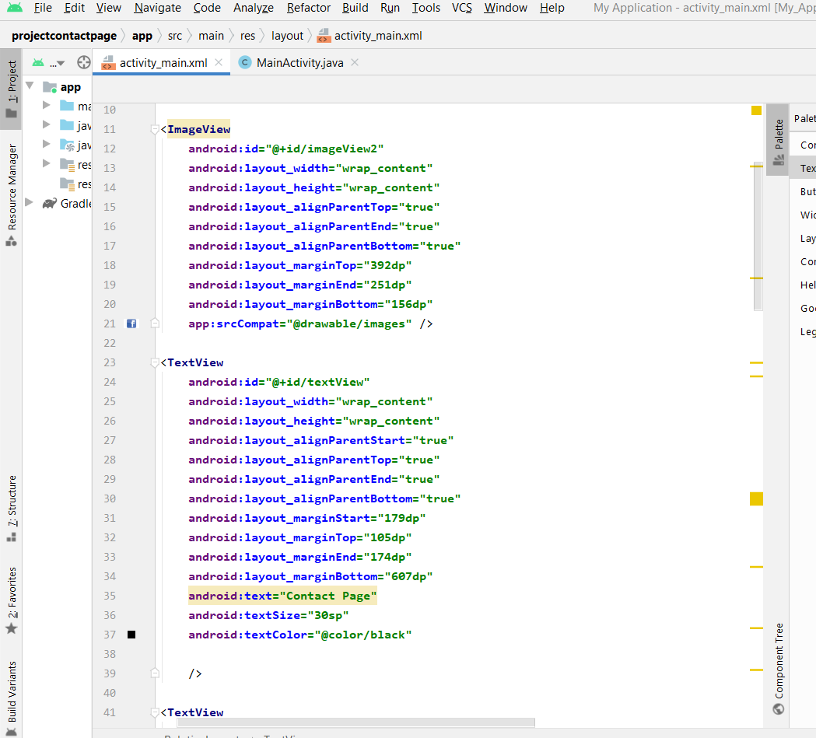

User face inter design

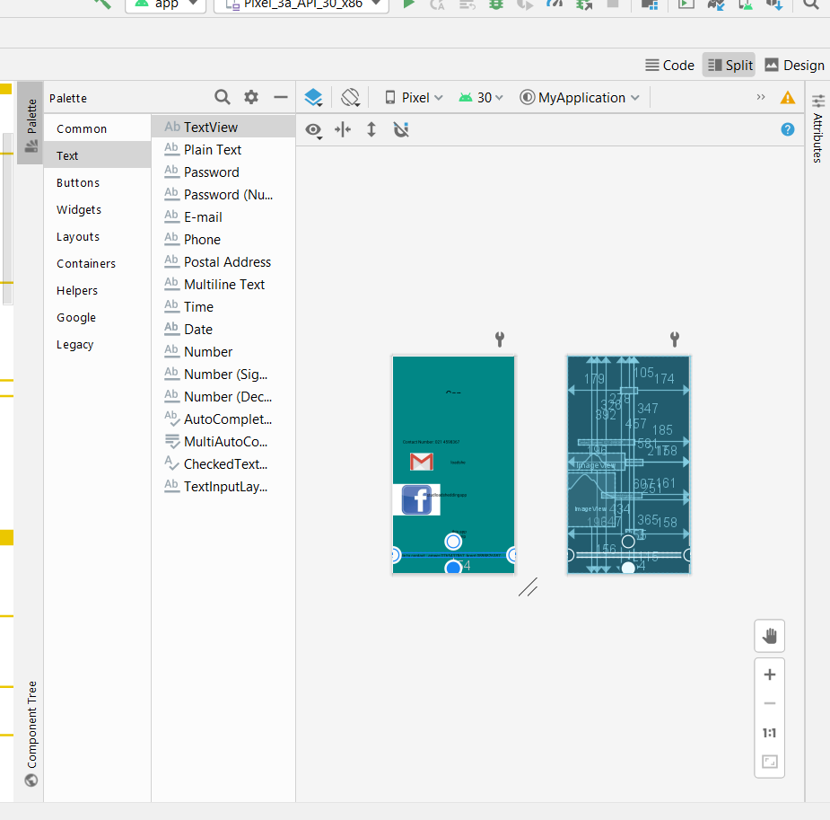

This one didn’t want to show on how it looks like on the device I really don’t know why , but the code builds and runs.

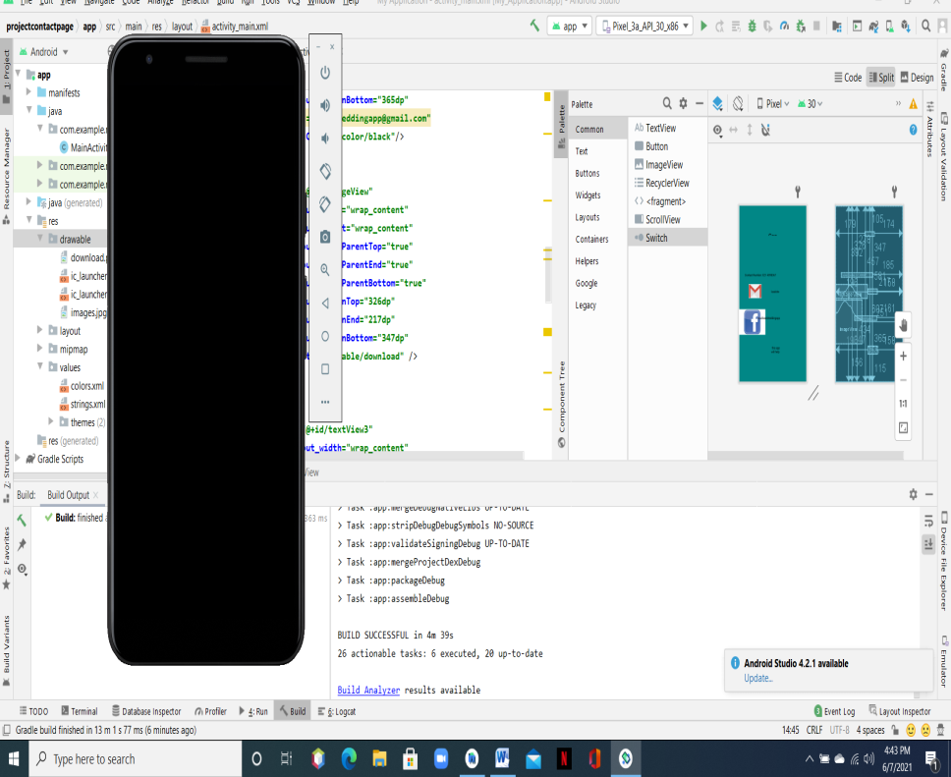

**Data base design**

This is a sketch of how all our pages link, I really can’t have a data base because In the front end coding there is nothing really to captor, that’s why I have this design sketch to show how our different parts will connect together.

Login page – Ameer

Registration page -warren

Function page-Marvin

Reset password page –Edvalter

Contact page – Brent hendricks

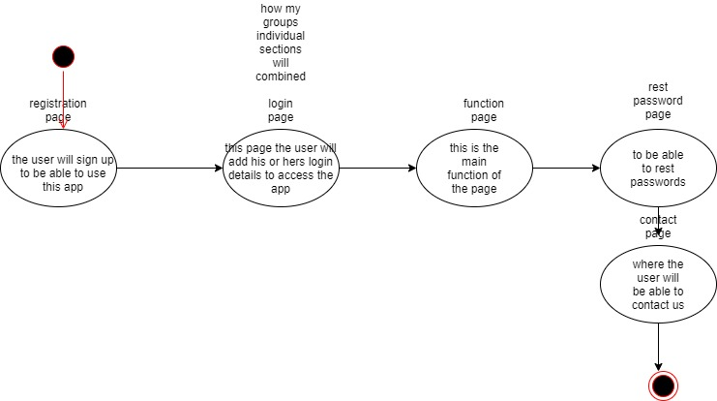

**Testing the system , subsystem**

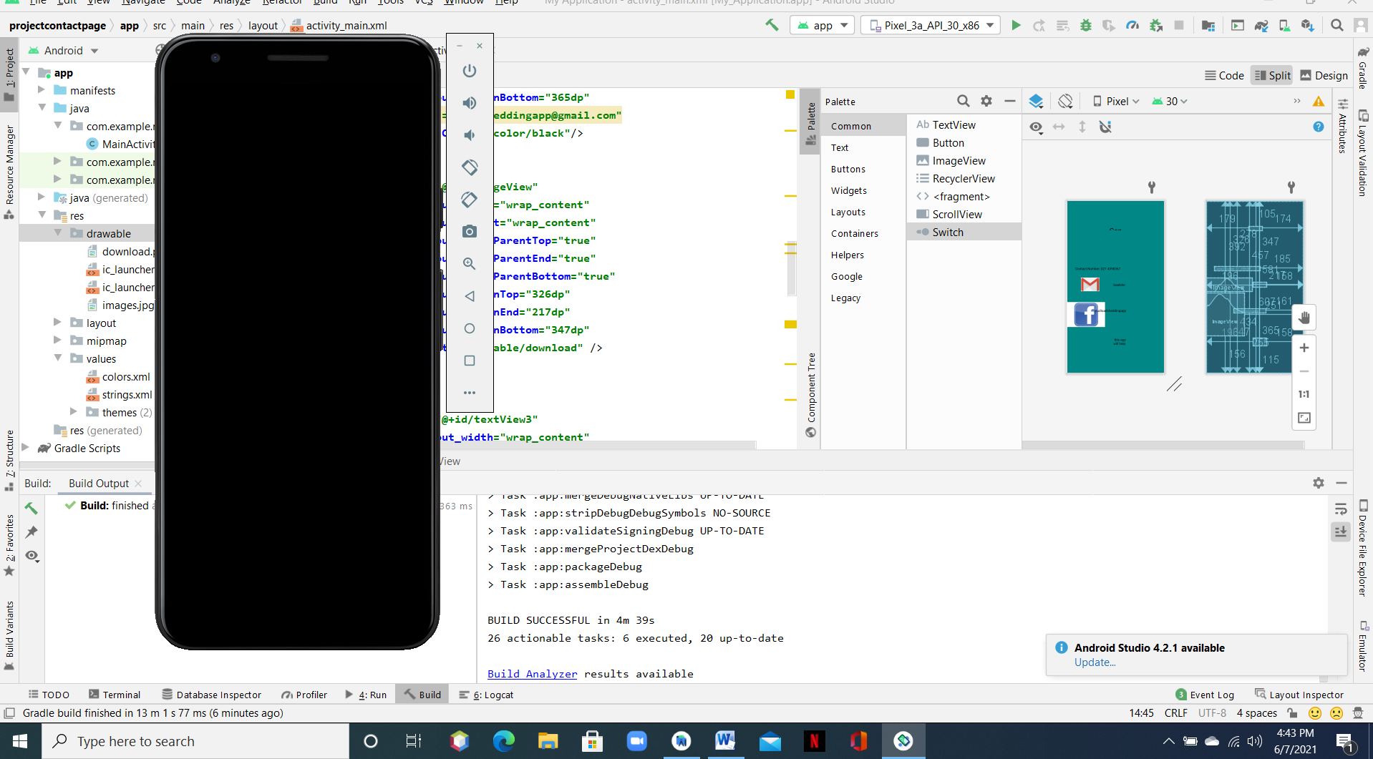

System built but the apk won’t show I don’t know why , iv also been having this problem with my elective android studio and have spoken to my lecturer about this.